Solar Calendar
# Source: AI Source: Provided by: [Data Path: Persons Table -> ID Column: 1, Name_En Column: Motasem Essam] -> From: [ChatGPT] on [7/17/2026]
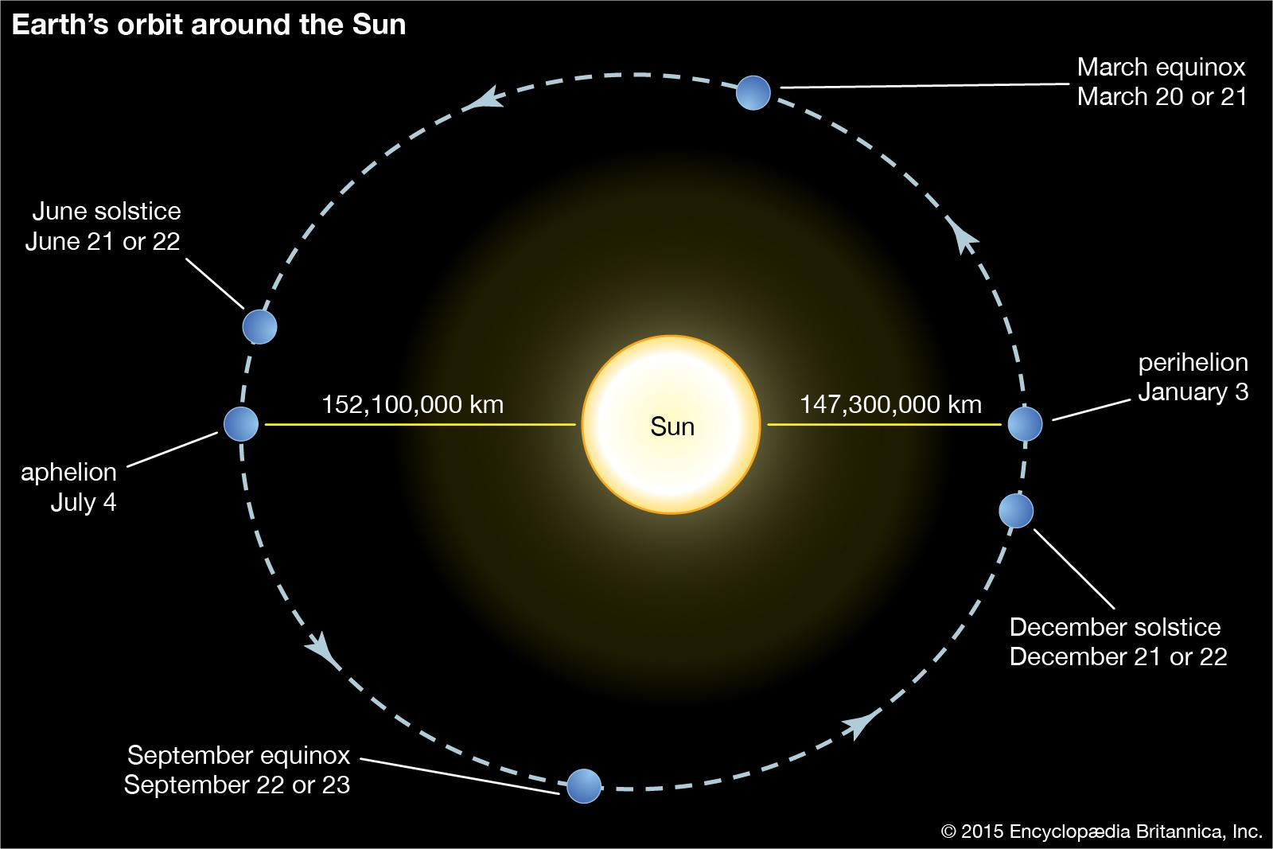
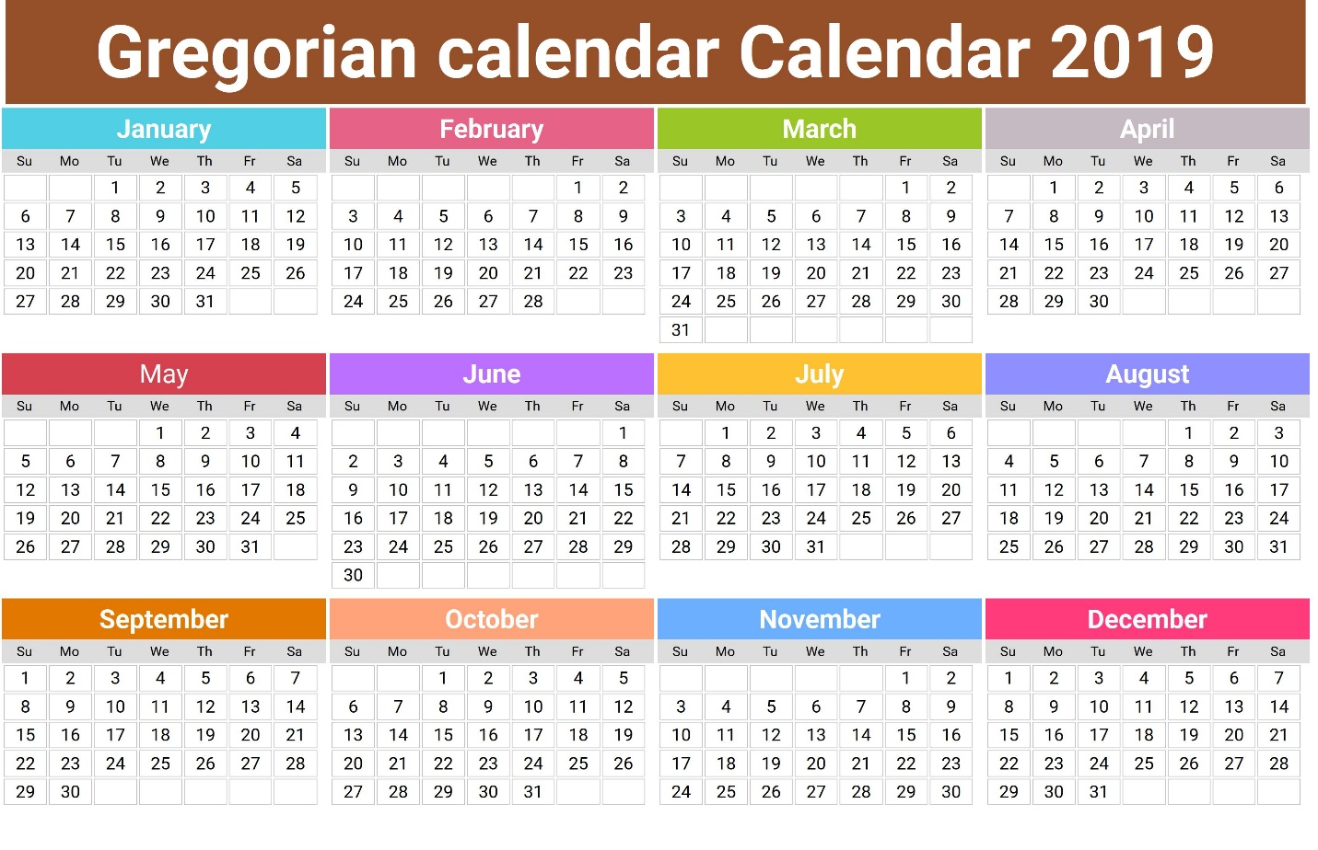
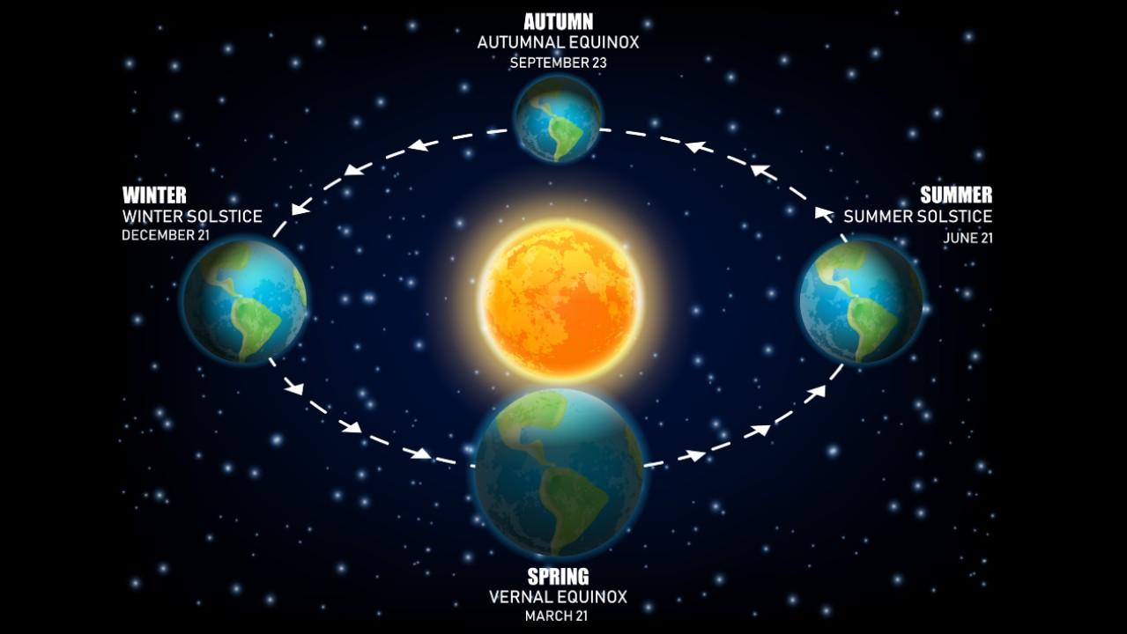
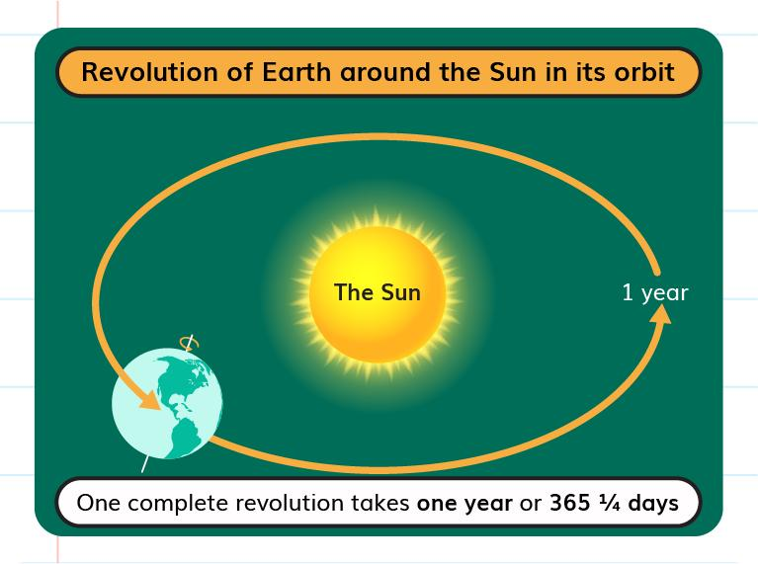
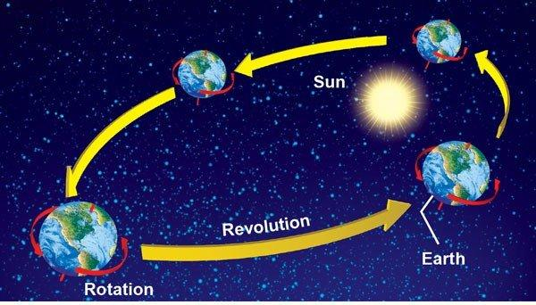
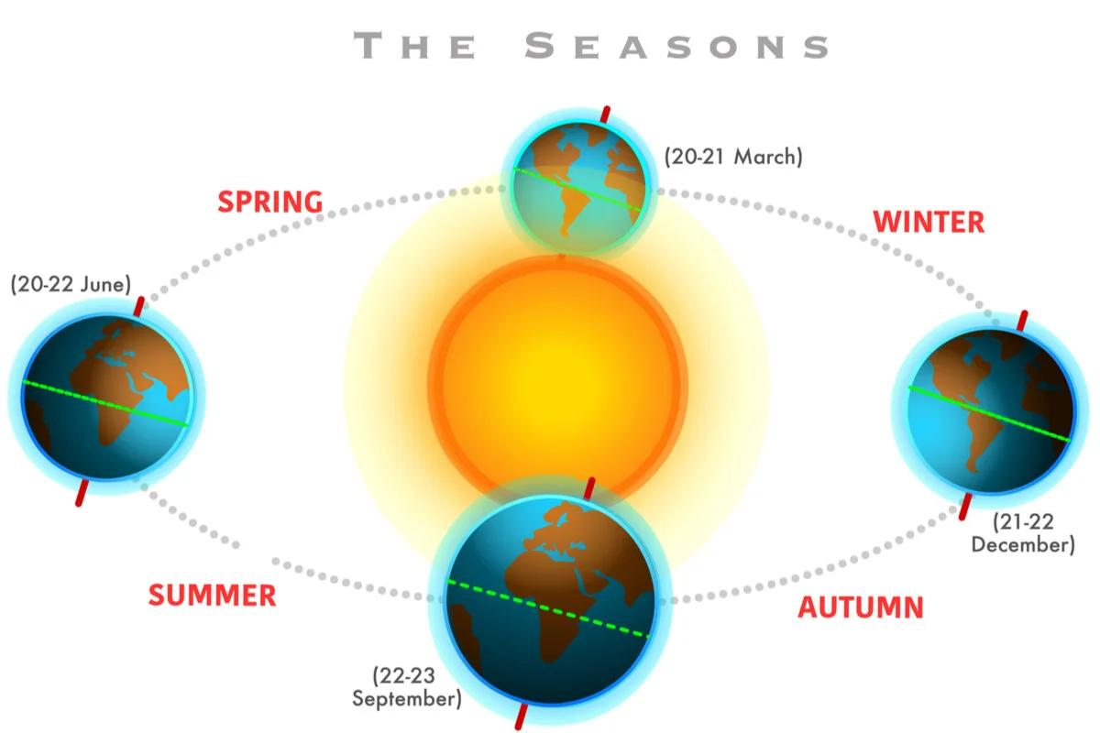
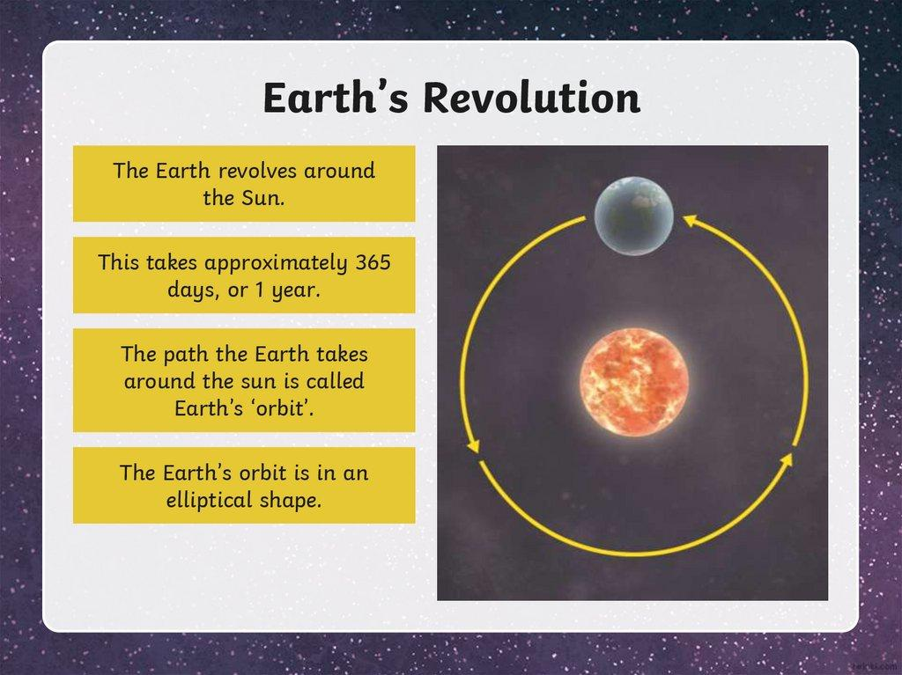
A Solar Calendar is a calendar system based on the Earth's revolution around the Sun. Its primary purpose is to keep the calendar synchronized with the seasons, making it especially useful for civil life, agriculture, education, science, and government.
Most countries today use a solar calendar, with the Gregorian Calendar being the most widely adopted example.

Definition
# Source: AI Source: Provided by: [Data Path: Persons Table -> ID Column: 1, Name_En Column: Motasem Essam] -> From: [ChatGPT] on [7/17/2026]
A Solar Calendar is a calendar system in which the length of the year is based on the Earth's complete orbit around the Sun.

Purpose
# Source: AI Source: Provided by: [Data Path: Persons Table -> ID Column: 1, Name_En Column: Motasem Essam] -> From: [ChatGPT] on [7/17/2026]
A solar calendar is designed to:
- Keep the calendar aligned with the seasons.
- Organize civil and governmental activities.
- Schedule education and business.
- Support agriculture.
- Record historical events.
- Measure long periods of time accurately.

Astronomical Basis
# Source: AI Source: Provided by: [Data Path: Persons Table -> ID Column: 1, Name_En Column: Motasem Essam] -> From: [ChatGPT] on [7/17/2026]
A solar calendar is based on one complete revolution of the Earth around the Sun.
The average length of a tropical (solar) year is approximately:
$$365.2422\text{ days}$$
Because this is not a whole number of days, most solar calendars use leap-year adjustments to maintain long-term accuracy.

Main Characteristics
# Source: AI Source: Provided by: [Data Path: Persons Table -> ID Column: 1, Name_En Column: Motasem Essam] -> From: [ChatGPT] on [7/17/2026]
A solar calendar typically has:
- 365 days in a common year.
- 366 days in a leap year.
- 12 months.
- Fixed progression of seasons.

Components
# Source: AI Source: Provided by: [Data Path: Persons Table -> ID Column: 1, Name_En Column: Motasem Essam] -> From: [ChatGPT] on [7/17/2026]
A solar calendar consists of:
- Day
- Week
- Month
- Year
- Leap year adjustment

Relationship to the Seasons
# Source: AI Source: Provided by: [Data Path: Persons Table -> ID Column: 1, Name_En Column: Motasem Essam] -> From: [ChatGPT] on [7/17/2026]
One of the main advantages of a solar calendar is that it remains synchronized with the seasons.
For example:
- Spring occurs in approximately the same months each year.
- Summer, autumn, and winter also remain in predictable periods.
This makes solar calendars especially useful for:
- Agriculture
- Climate observations
- School years
- National holidays

Types of Solar Calendars

1. Gregorian Calendar
# Source: AI Source: Provided by: [Data Path: Persons Table -> ID Column: 1, Name_En Column: Motasem Essam] -> From: [ChatGPT] on [7/17/2026]
Characteristics
- Introduced in 1582
- Official civil calendar in most countries
- Uses the 4–100–400 leap-year rule
- Average year length:
$$365.2425\text{ days}$$

2. Julian Calendar
# Source: AI Source: Provided by: [Data Path: Persons Table -> ID Column: 1, Name_En Column: Motasem Essam] -> From: [ChatGPT] on [7/17/2026]
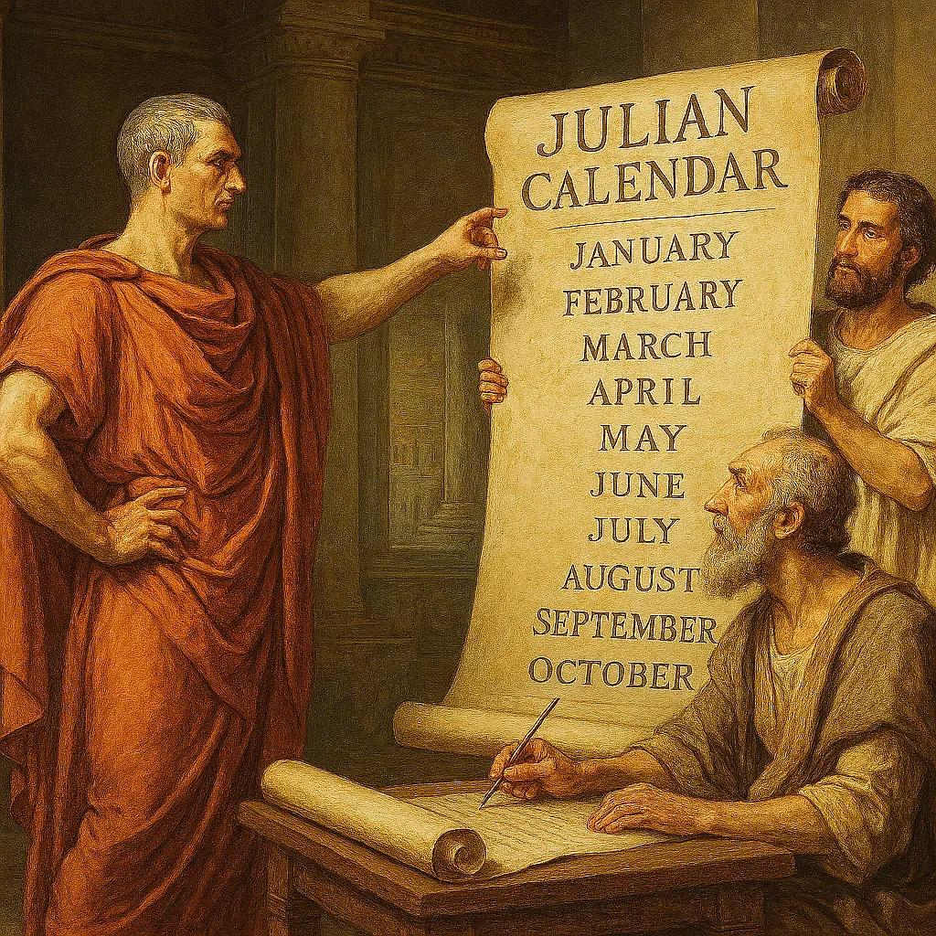
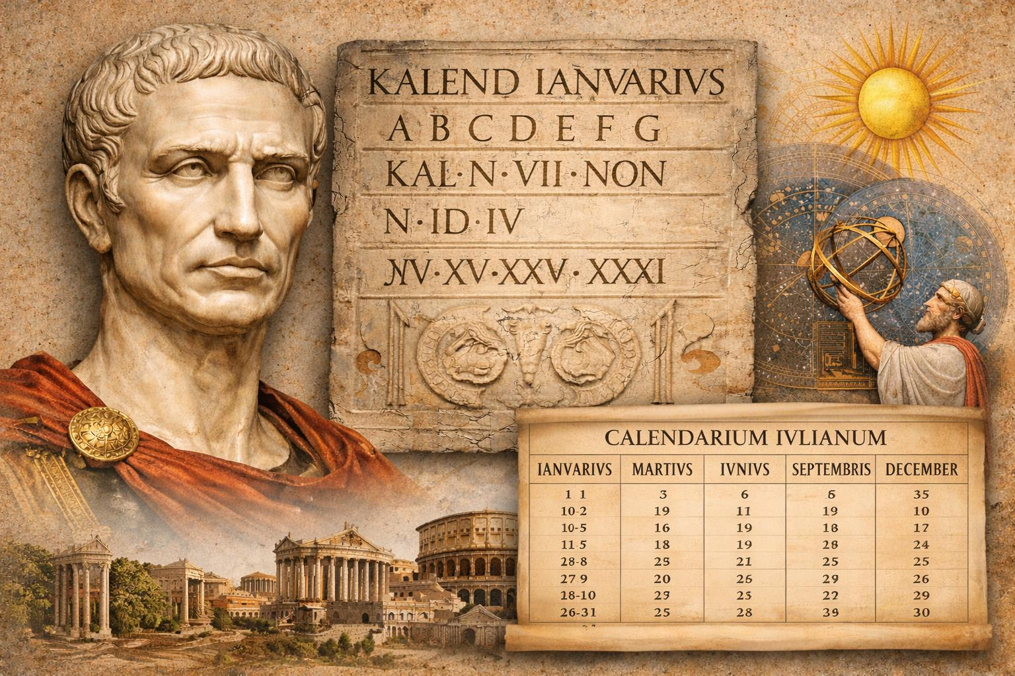
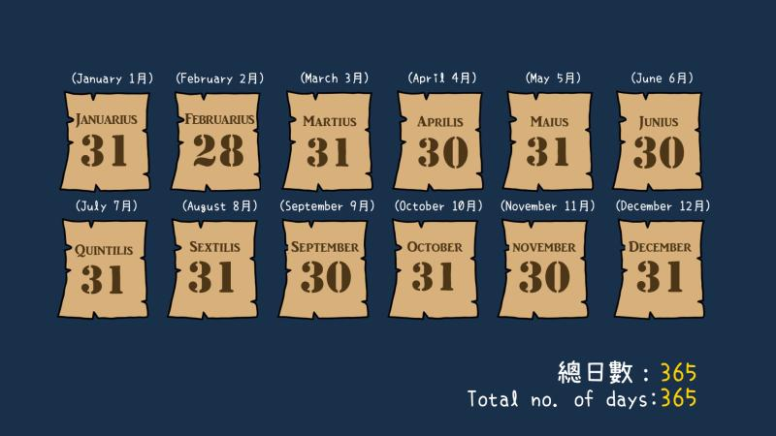
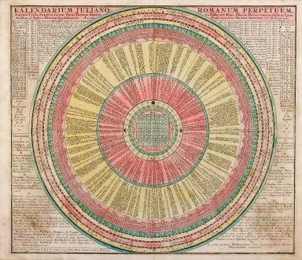
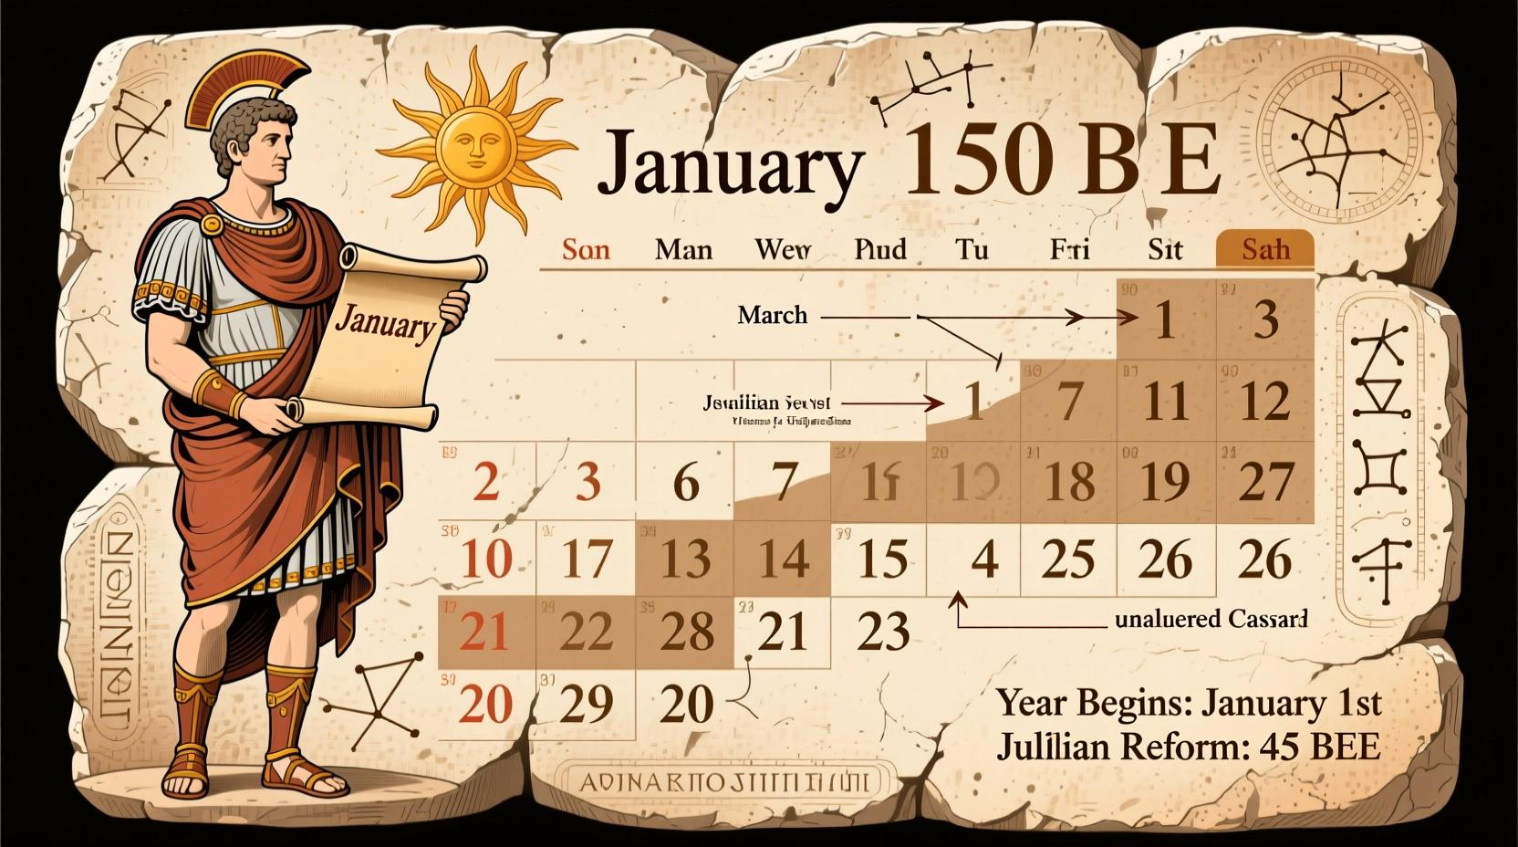
Characteristics
- Introduced in 45 BCE
- Leap year every four years
- Average year:
$$365.25\text{ days}$$
Less accurate than the Gregorian Calendar because it gains about one day every 128 years relative to the tropical year.

3. Persian (Solar Hijri) Calendar
# Source: AI Source: Provided by: [Data Path: Persons Table -> ID Column: 1, Name_En Column: Motasem Essam] -> From: [ChatGPT] on [7/17/2026]
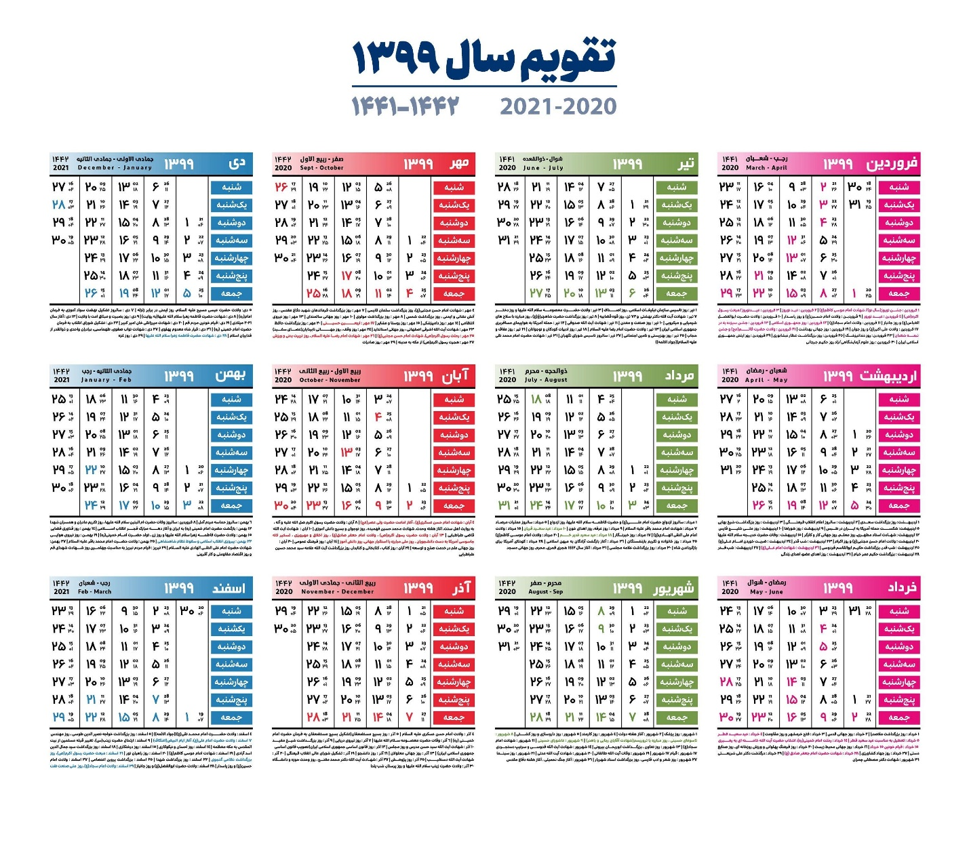
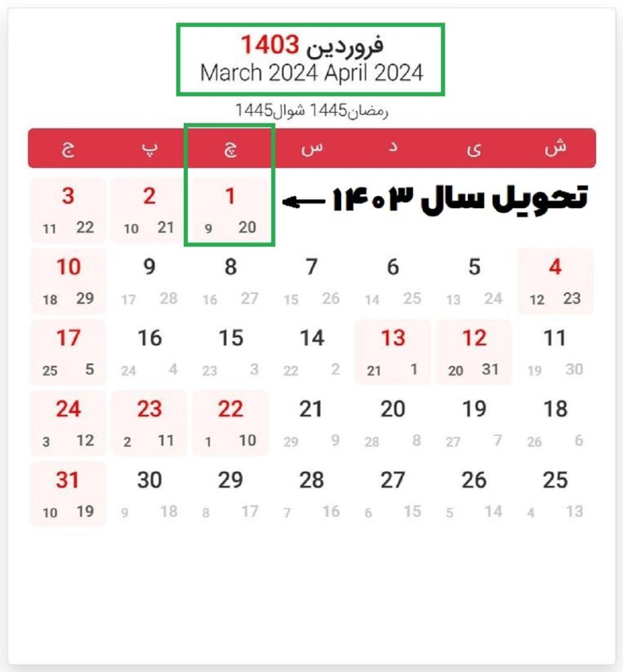

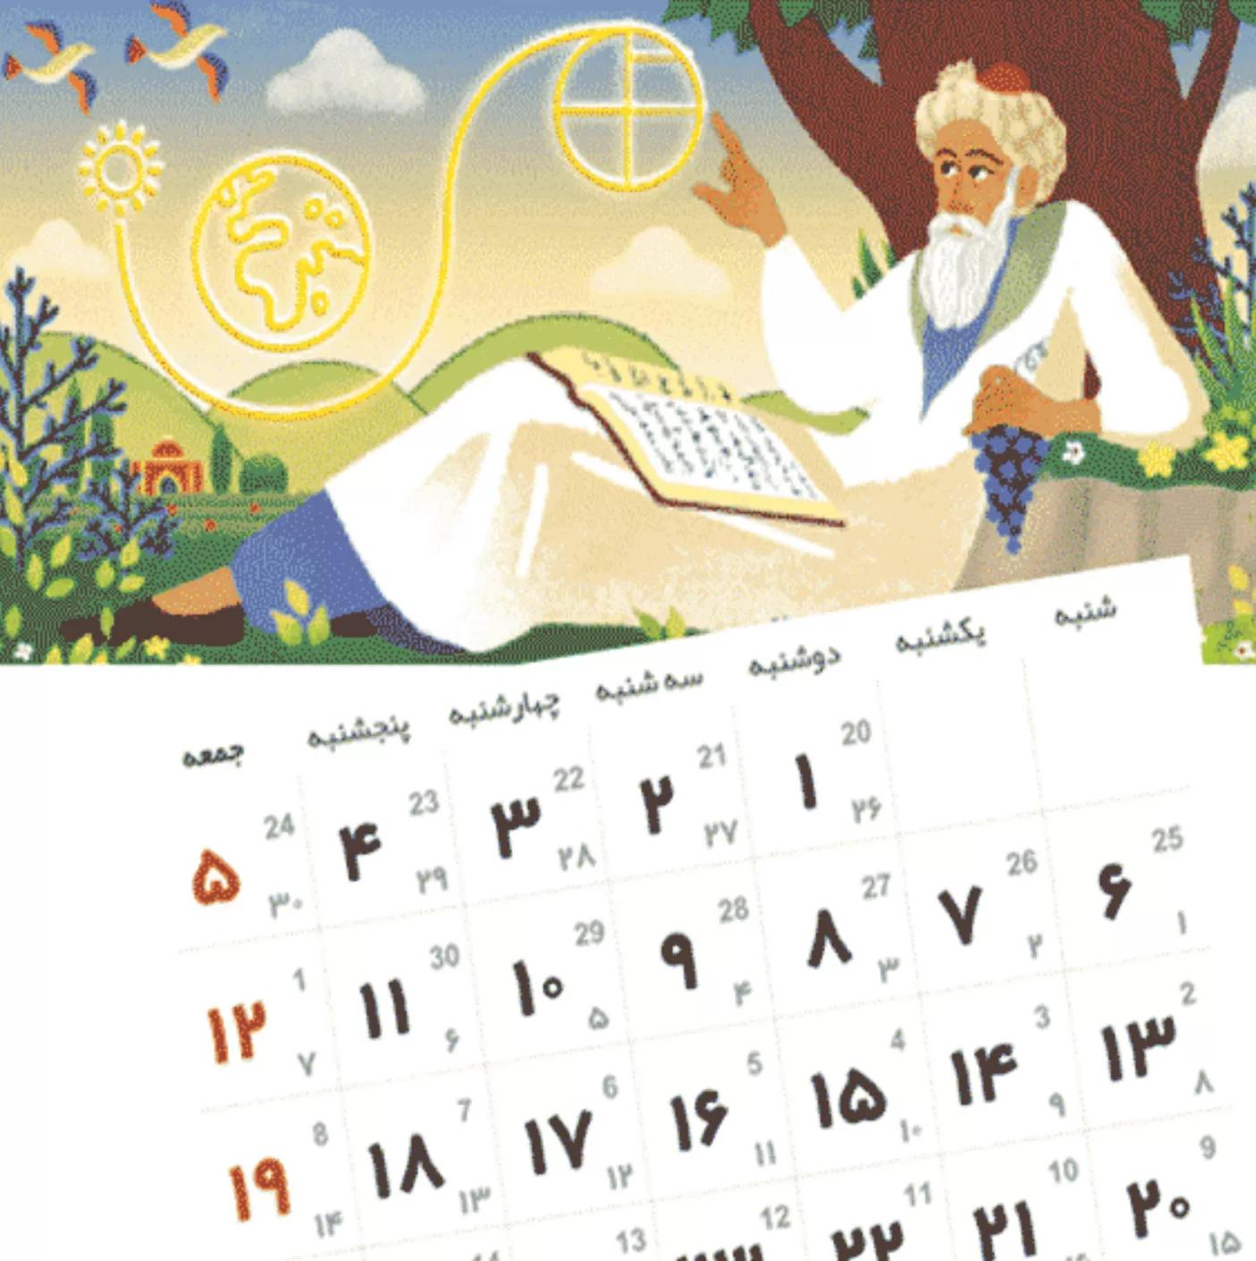
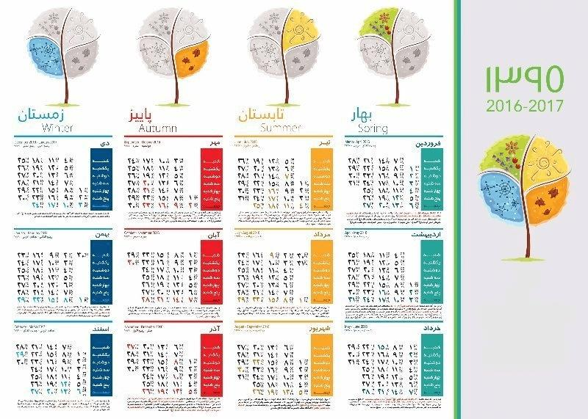
Characteristics
- Begins at the astronomical spring equinox
- Official calendar of Iran and Afghanistan
- One of the most accurate solar calendars in use today
- Average year length is very close to the tropical year.

Leap Year
# Source: AI Source: Provided by: [Data Path: Persons Table -> ID Column: 1, Name_En Column: Motasem Essam] -> From: [ChatGPT] on [7/17/2026]
Since the Earth's orbit is about 365.2422 days, solar calendars add extra days periodically.
Examples:
- Gregorian Calendar:
  - Leap year every four years, with century-year exceptions.
- Julian Calendar:
  - Leap year every four years.
- Persian Calendar:
  - Leap years determined by astronomical calculations tied to the spring equinox.

Advantages
# Source: AI Source: Provided by: [Data Path: Persons Table -> ID Column: 1, Name_En Column: Motasem Essam] -> From: [ChatGPT] on [7/17/2026]
Solar calendars:
- Stay aligned with the seasons.
- Support agriculture.
- Simplify long-term planning.
- Provide predictable civil schedules.
- Are suitable for scientific observations.

Limitations
# Source: AI Source: Provided by: [Data Path: Persons Table -> ID Column: 1, Name_En Column: Motasem Essam] -> From: [ChatGPT] on [7/17/2026]
Solar calendars:
- Require leap-year adjustments.
- Are not synchronized with lunar phases.
- Do not naturally determine lunar-based religious events.

Applications
# Source: AI Source: Provided by: [Data Path: Persons Table -> ID Column: 1, Name_En Column: Motasem Essam] -> From: [ChatGPT] on [7/17/2026]
Solar calendars are used in:
- Government
- Education
- Banking
- Science
- Engineering
- Agriculture
- Transportation
- Business
- International communication

Comparison with Other Calendar Types
# Source: AI Source: Provided by: [Data Path: Persons Table -> ID Column: 1, Name_En Column: Motasem Essam] -> From: [ChatGPT] on [7/17/2026]
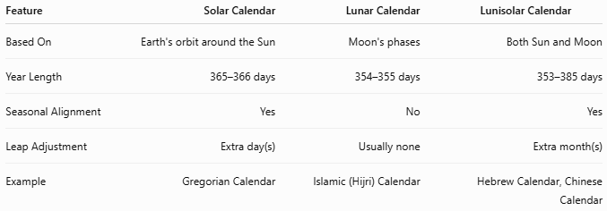
Feature | Solar Calendar | Lunar Calendar | Lunisolar Calendar
Based On | Earth's orbit around the Sun | Moon's phases | Both Sun and Moon
Year Length | 365–366 days | 354–355 days | 353–385 days
Seasonal Alignment | Yes | No | Yes
Leap Adjustment | Extra day(s) | Usually none | Extra month(s)
Example | Gregorian Calendar | Islamic (Hijri) Calendar | Hebrew Calendar, Chinese Calendar

Common Mistakes
# Source: AI Source: Provided by: [Data Path: Persons Table -> ID Column: 1, Name_En Column: Motasem Essam] -> From: [ChatGPT] on [7/17/2026]
- Confusing a solar calendar with a lunar calendar.
- Assuming every year contains exactly 365 days.
- Forgetting leap-year adjustments.
- Assuming all solar calendars use the same leap-year rules.

Key Points
# Source: AI Source: Provided by: [Data Path: Persons Table -> ID Column: 1, Name_En Column: Motasem Essam] -> From: [ChatGPT] on [7/17/2026]
- A Solar Calendar measures the year using the Earth's revolution around the Sun.
- The average solar year is approximately:
$$365.2422\text{ days}$$
- Most solar calendars contain:
  - 365 days in a common year.
  - 366 days in a leap year.
- Solar calendars remain synchronized with the seasons.
- Major examples include:
  - Gregorian Calendar
  - Julian Calendar
  - Persian (Solar Hijri) Calendar

Conclusion
# Source: AI Source: Provided by: [Data Path: Persons Table -> ID Column: 1, Name_En Column: Motasem Essam] -> From: [ChatGPT] on [7/17/2026]
A Solar Calendar is a calendar system based on the Earth's annual revolution around the Sun, making it well suited for organizing civil life and maintaining alignment with the seasons. By using leap-year adjustments to account for the fractional length of the solar year, it provides a stable framework for government, education, agriculture, business, and scientific activities. The Gregorian Calendar, Julian Calendar, and Persian (Solar Hijri) Calendar are among the best-known examples, each using different methods to achieve accurate long-term timekeeping.

